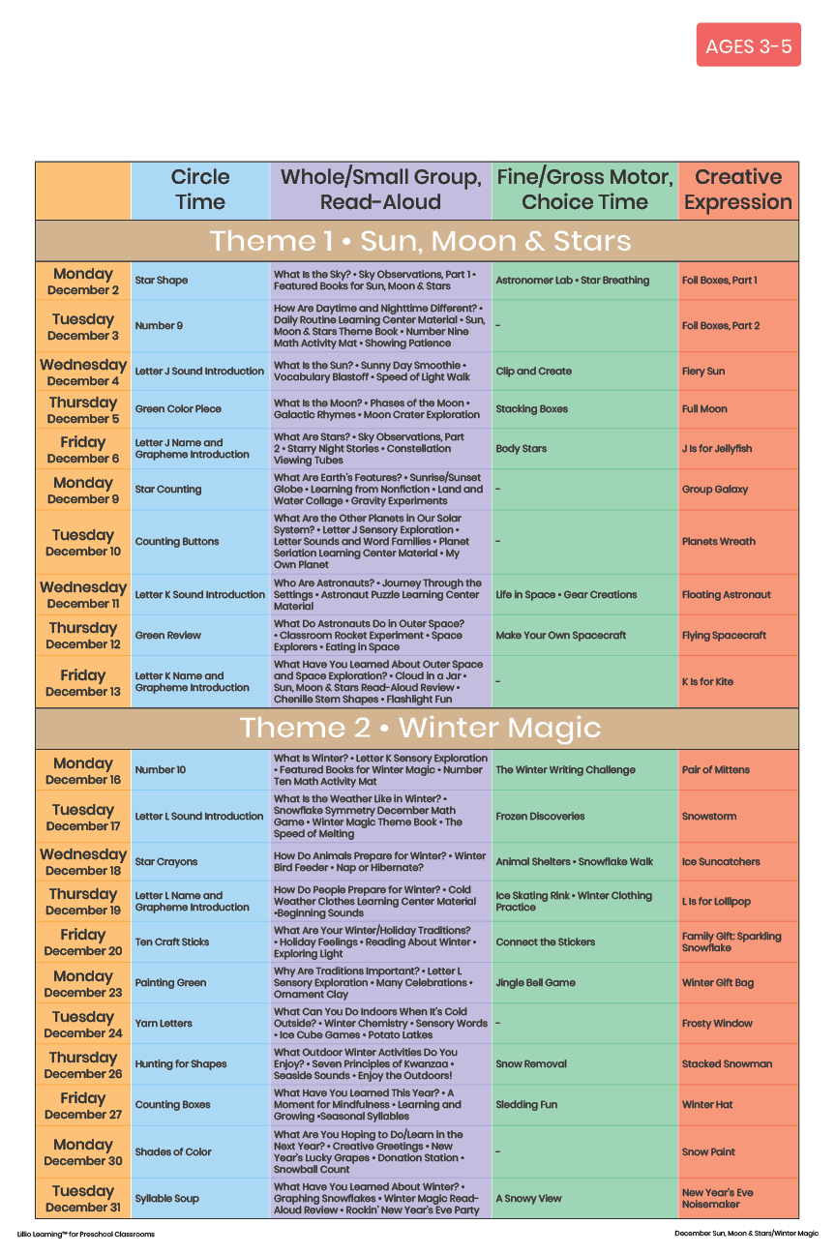

December 2024

Add Your Name/Logo Here