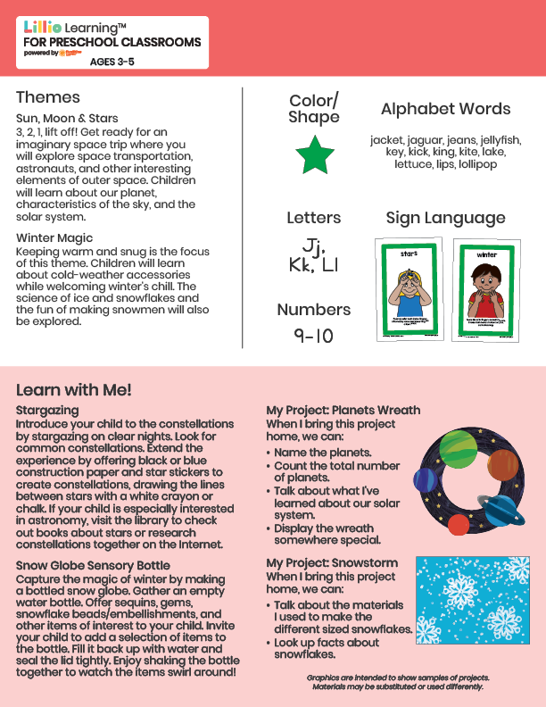­

Add Your Name/Logo Here

December 2024

Newsletter

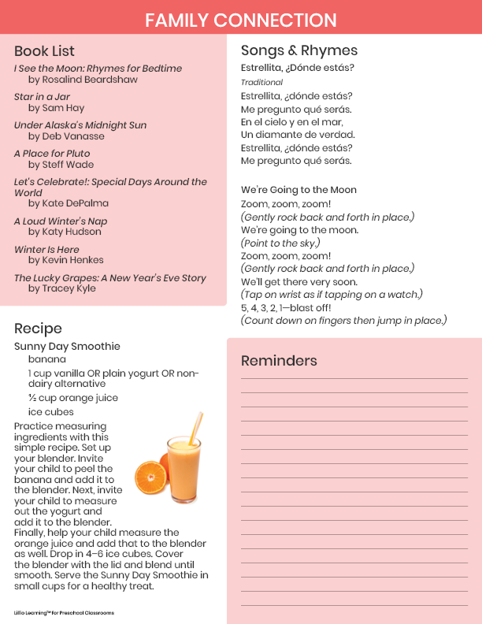

Add Notes