**Add Your Name/Logo Here**

December 2023

Newsletter

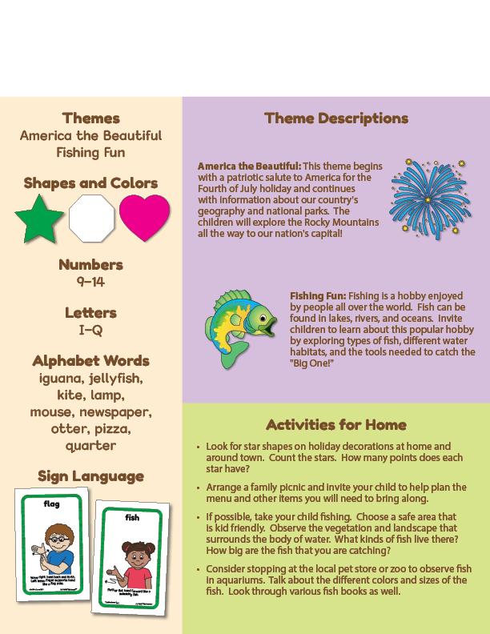Newsletter

­

**Add Notes**