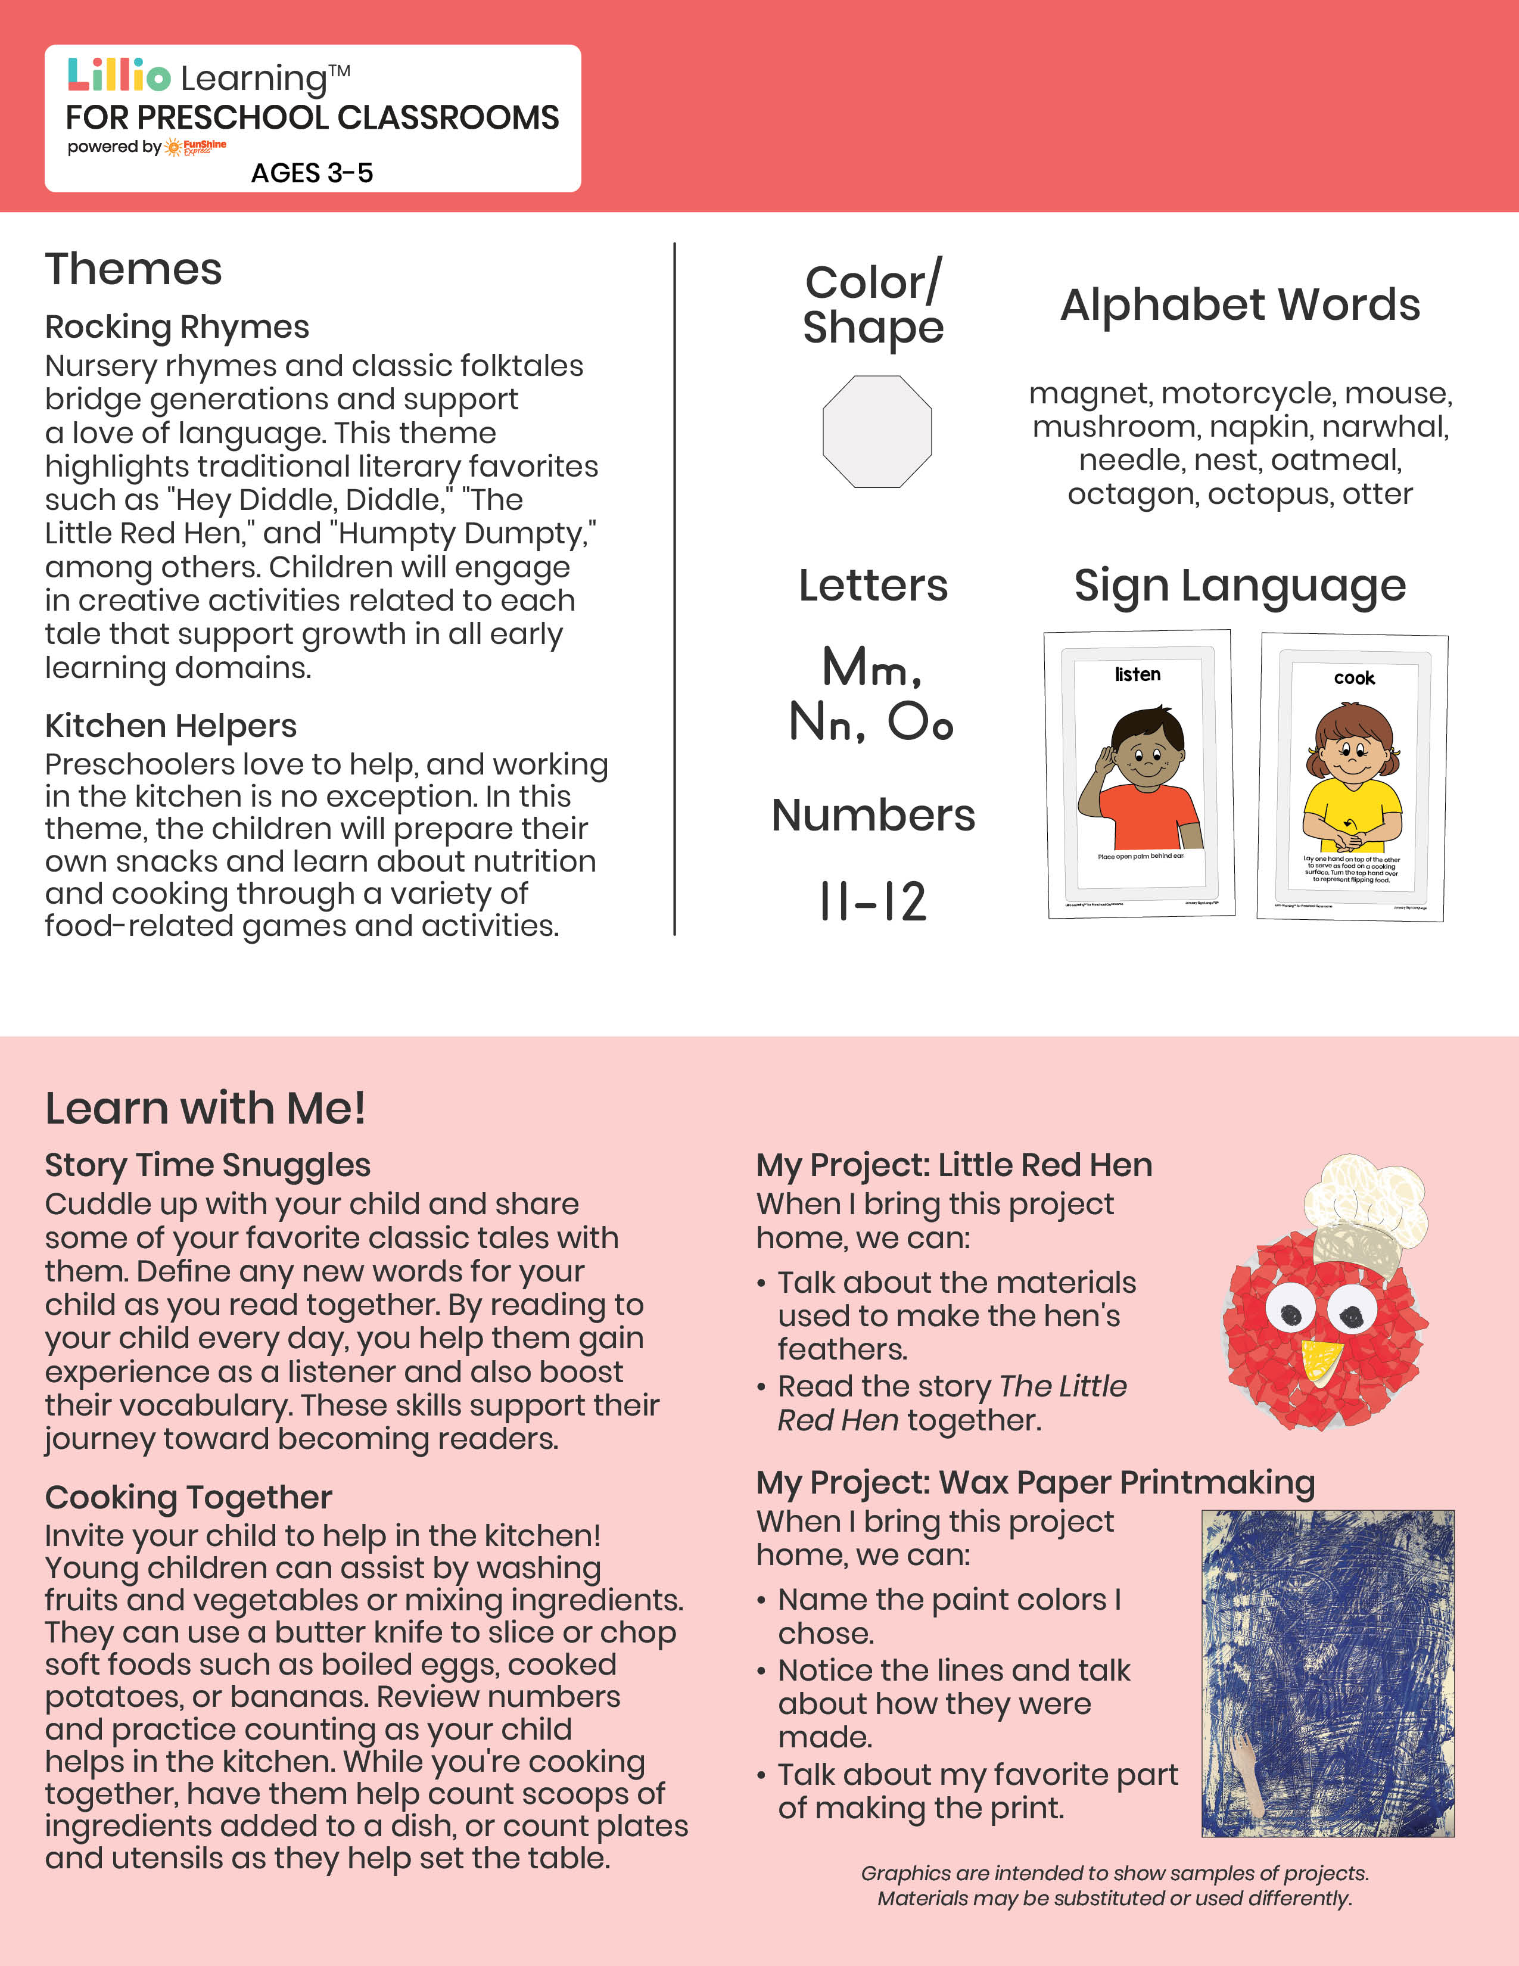­

Add Your Name/Logo Here

January 2025

Newsletter

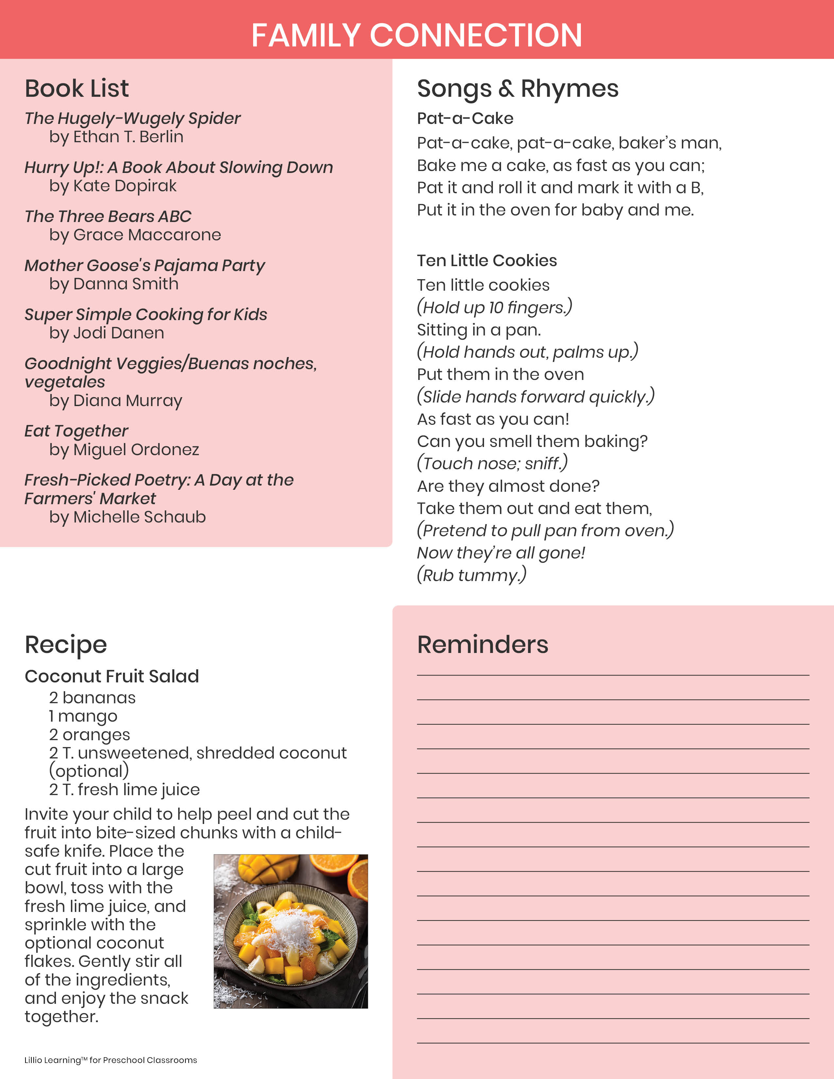

Add Notes