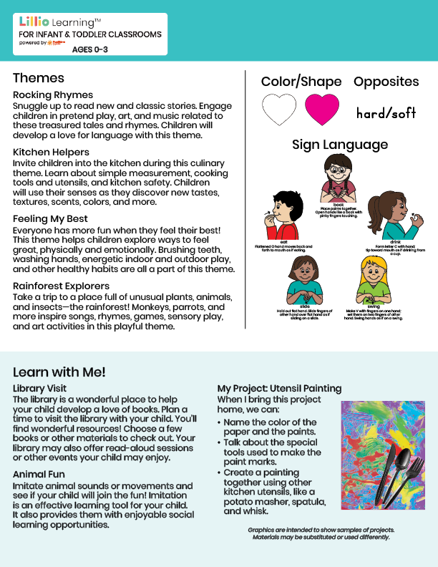

Jan/Feb 2025

NEWSLETTER

Add Name or Logo Here

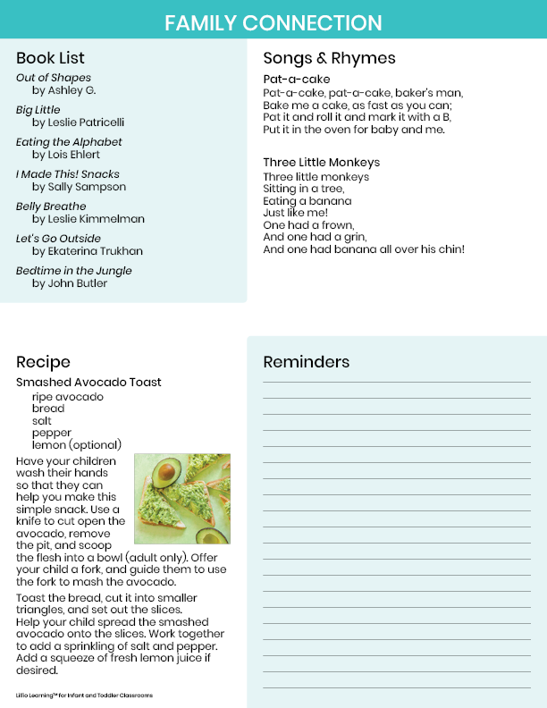

Add Notes Here