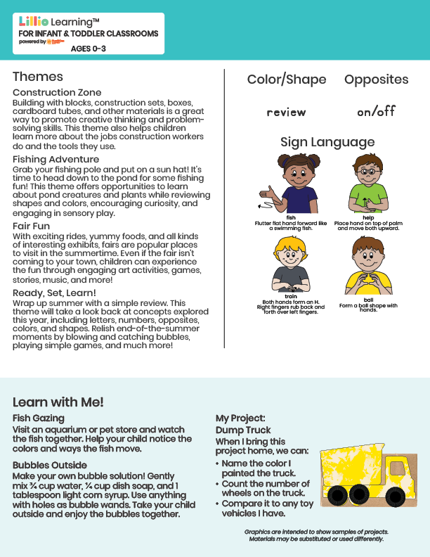

Add Name or Logo Here

July/Aug 2025

NEWSLETTER

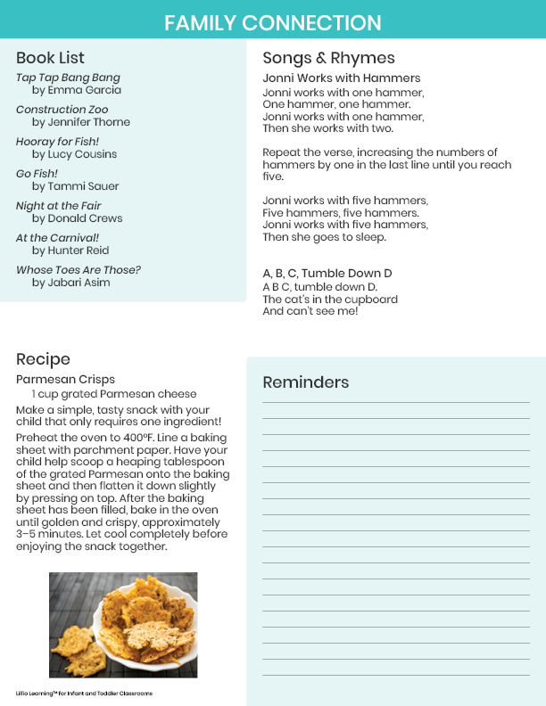

Add Notes Here