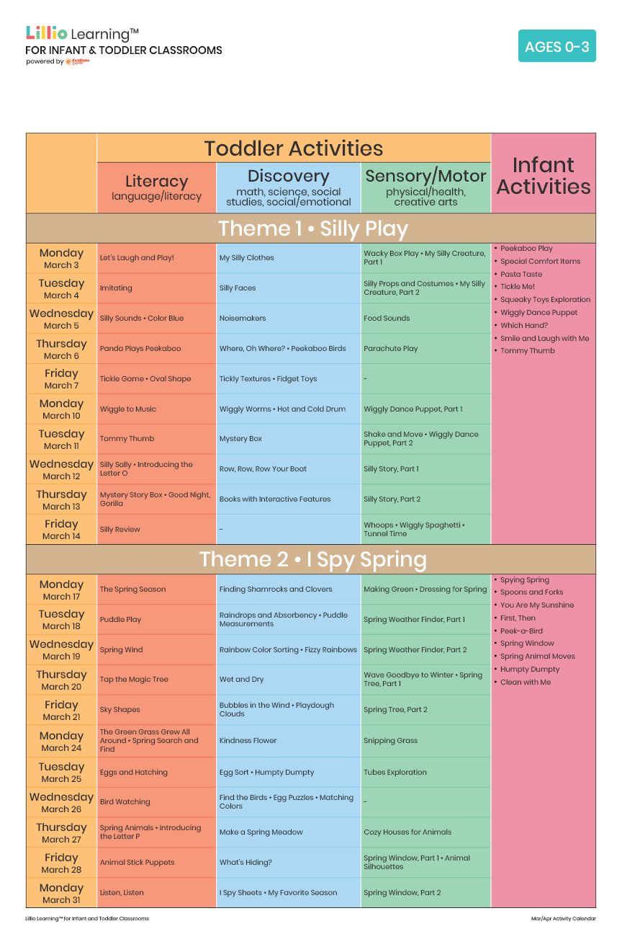

March 2025

Add Your Name/Logo Here

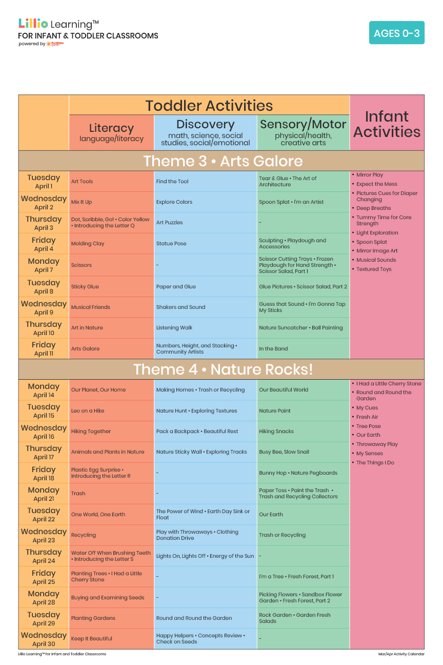

April 2025

Add Your Name/Logo Here