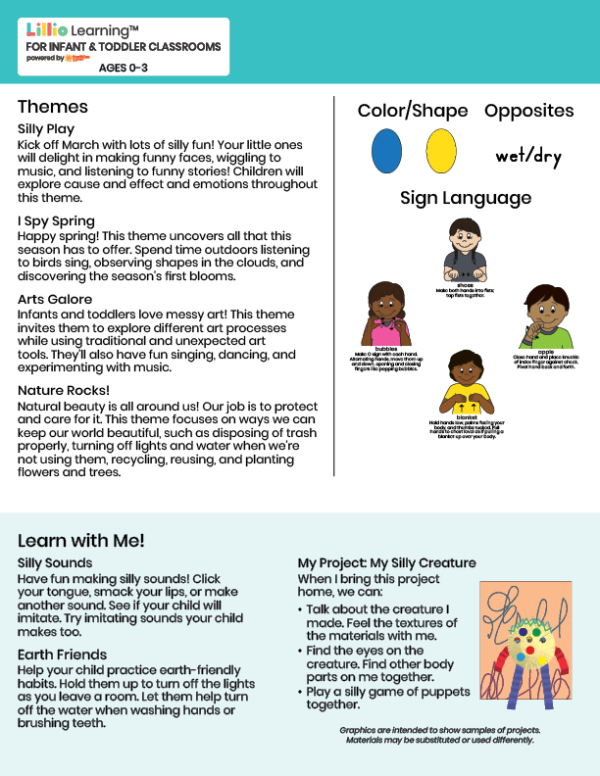

Mar/Apr 2025

NEWSLETTER

Add Name or Logo Here

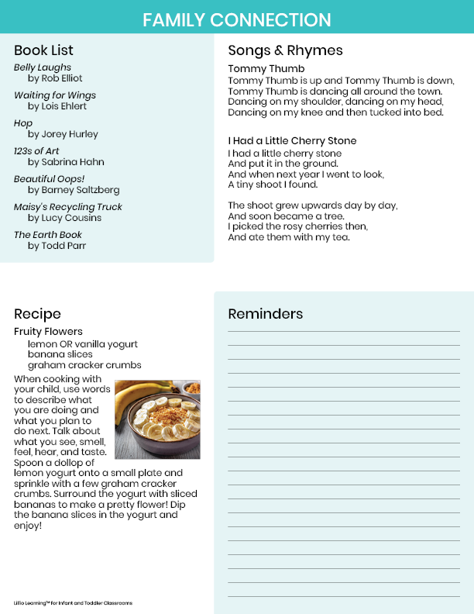

Add Notes Here