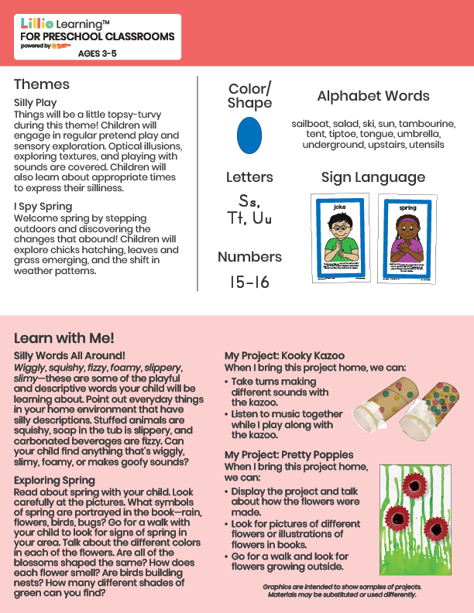­

Add Your Name/Logo Here

March 2025

Newsletter

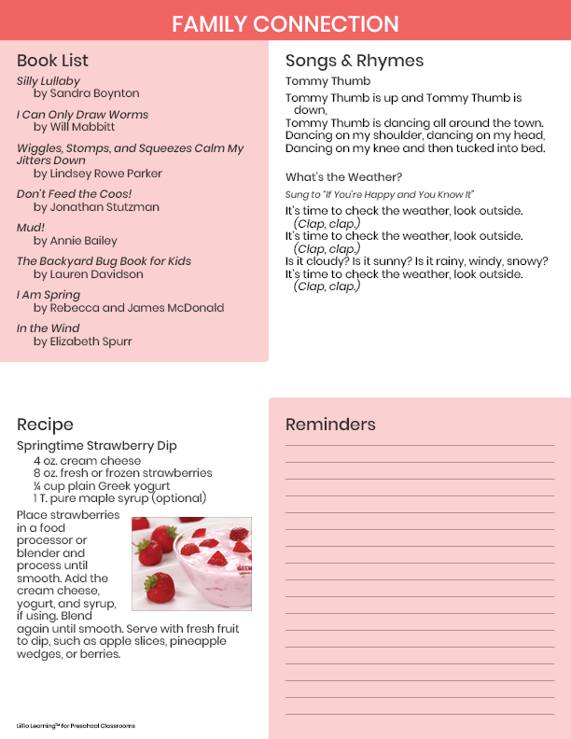

Add Notes