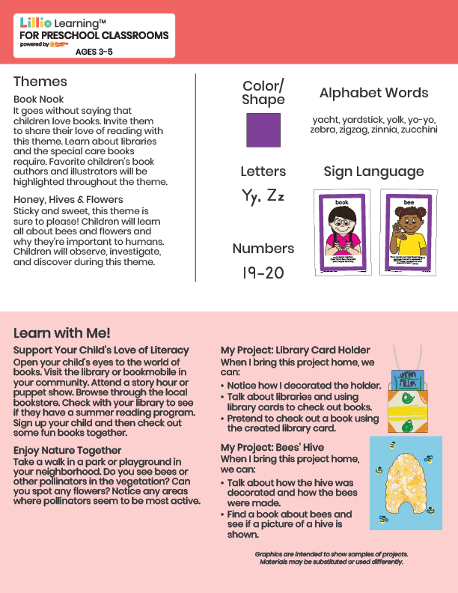­

Add Your Name/Logo Here

May 2025

Newsletter

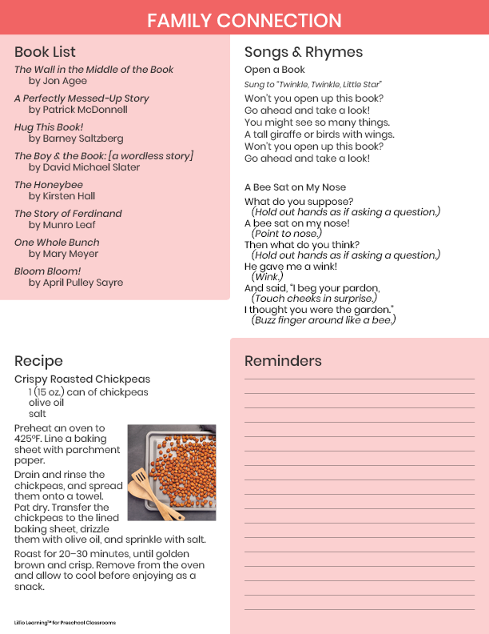

Add Notes