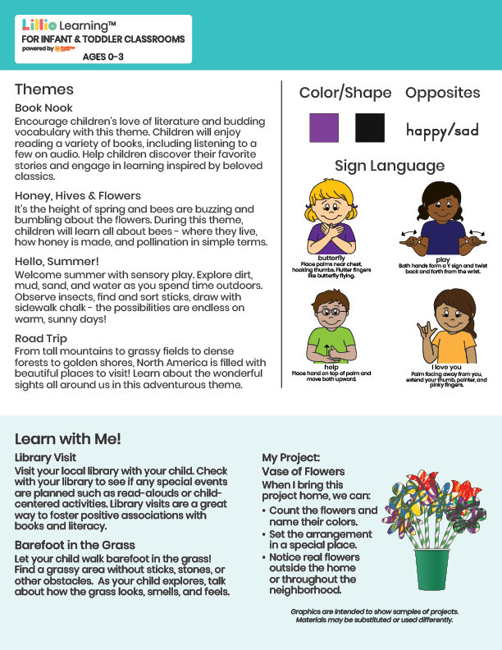

Add Name or Logo Here

May/June 2025

NEWSLETTER

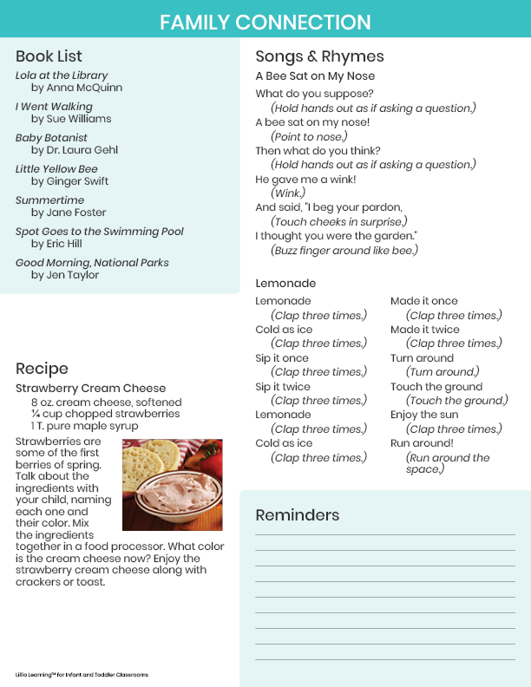

Add Notes Here