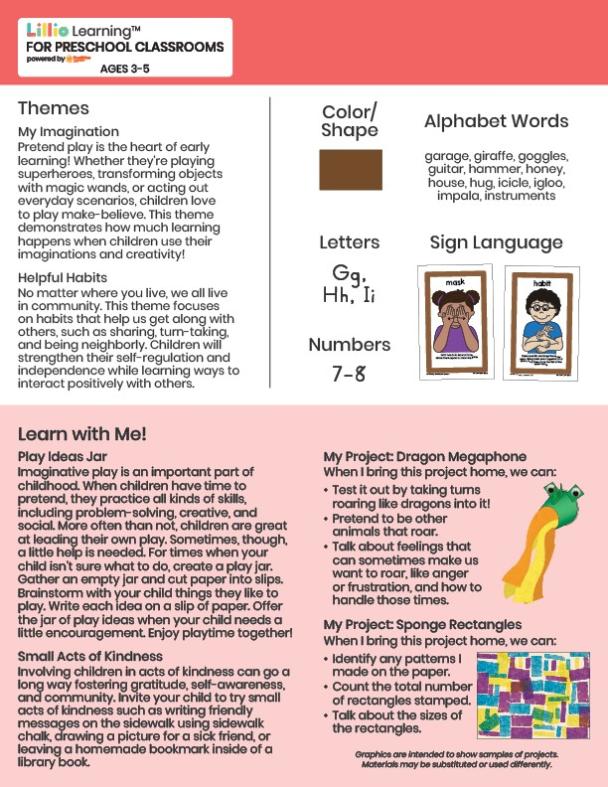­

Add Your Name/Logo Here

November 2024

Newsletter

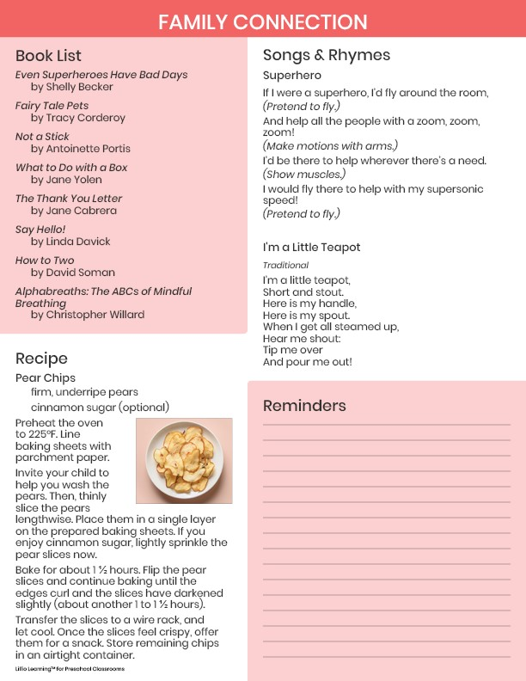

Add Notes