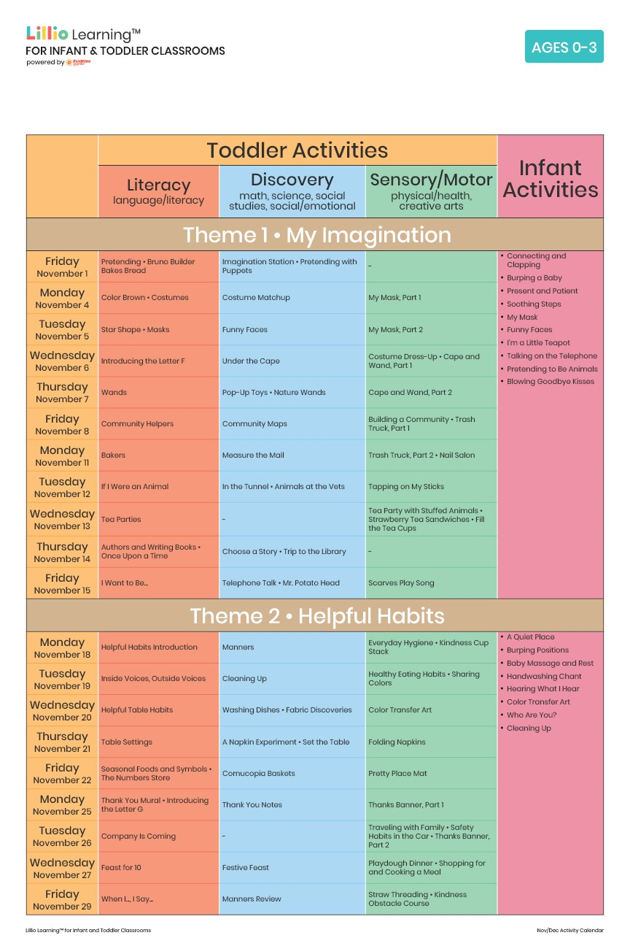

November 2024

Add Your Name/Logo Here

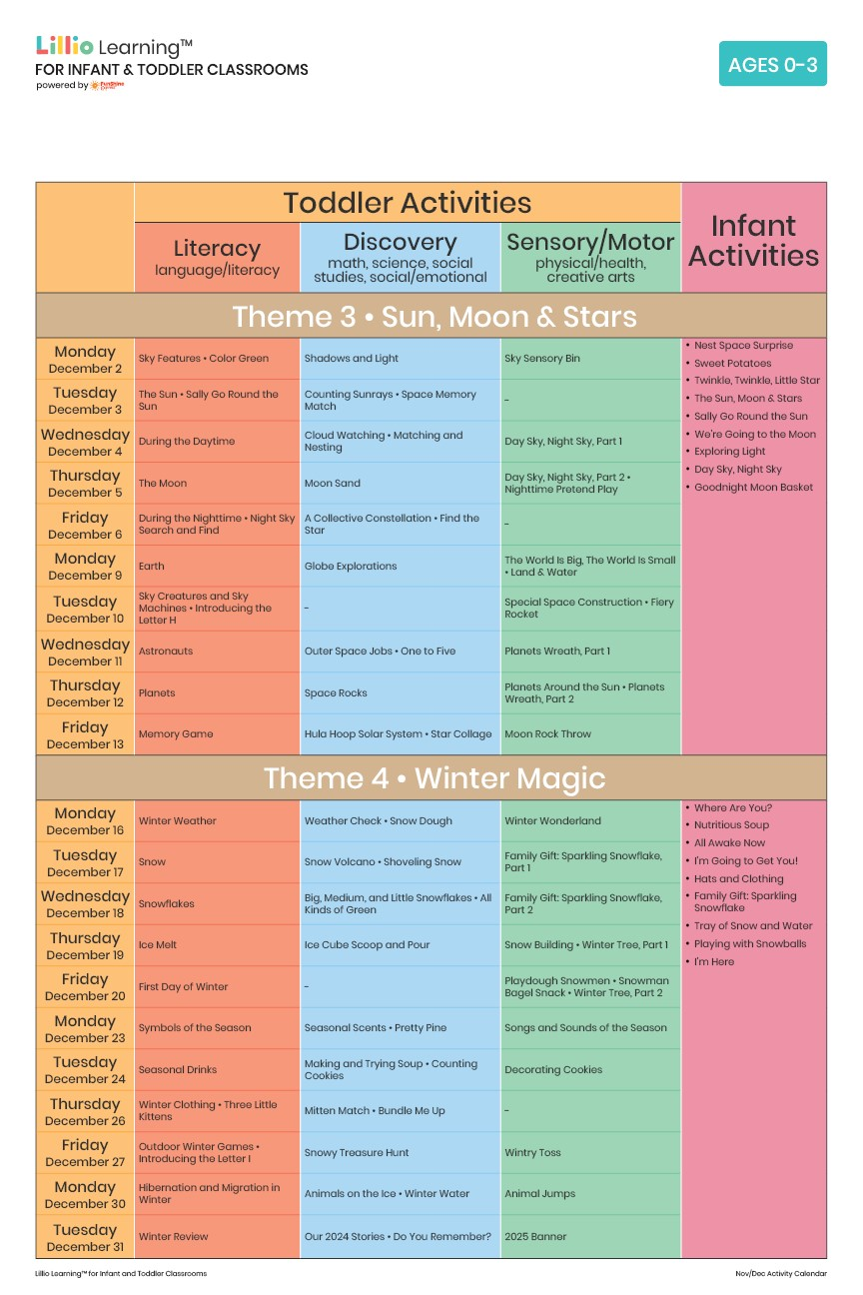

Add Your Name/Logo Here

December 2024