**Add Your Name/Logo Here**

November 2023

Newsletter

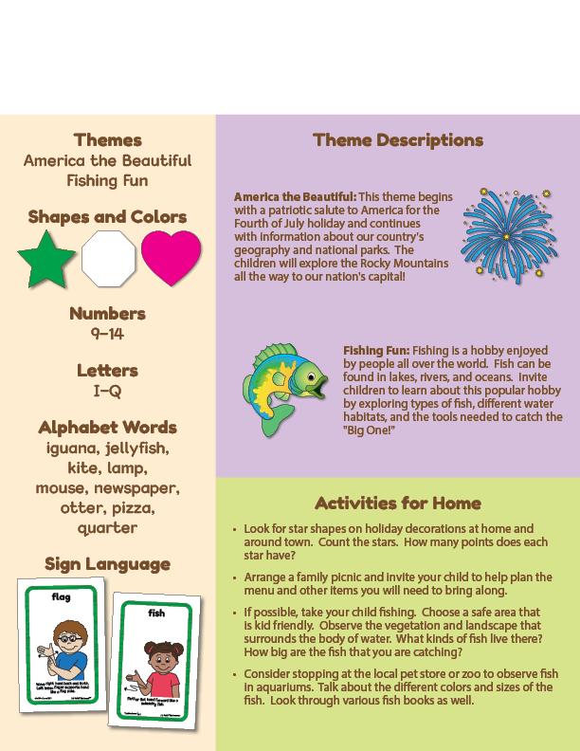Newsletter

­