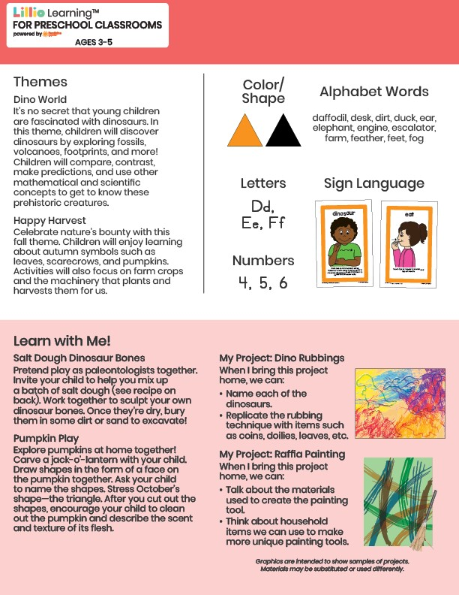­

October 2024

NEWSLETTER

Add Your Name/Logo Here

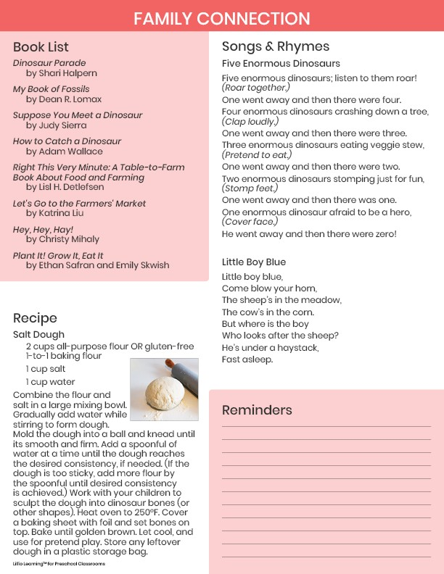

Add Notes