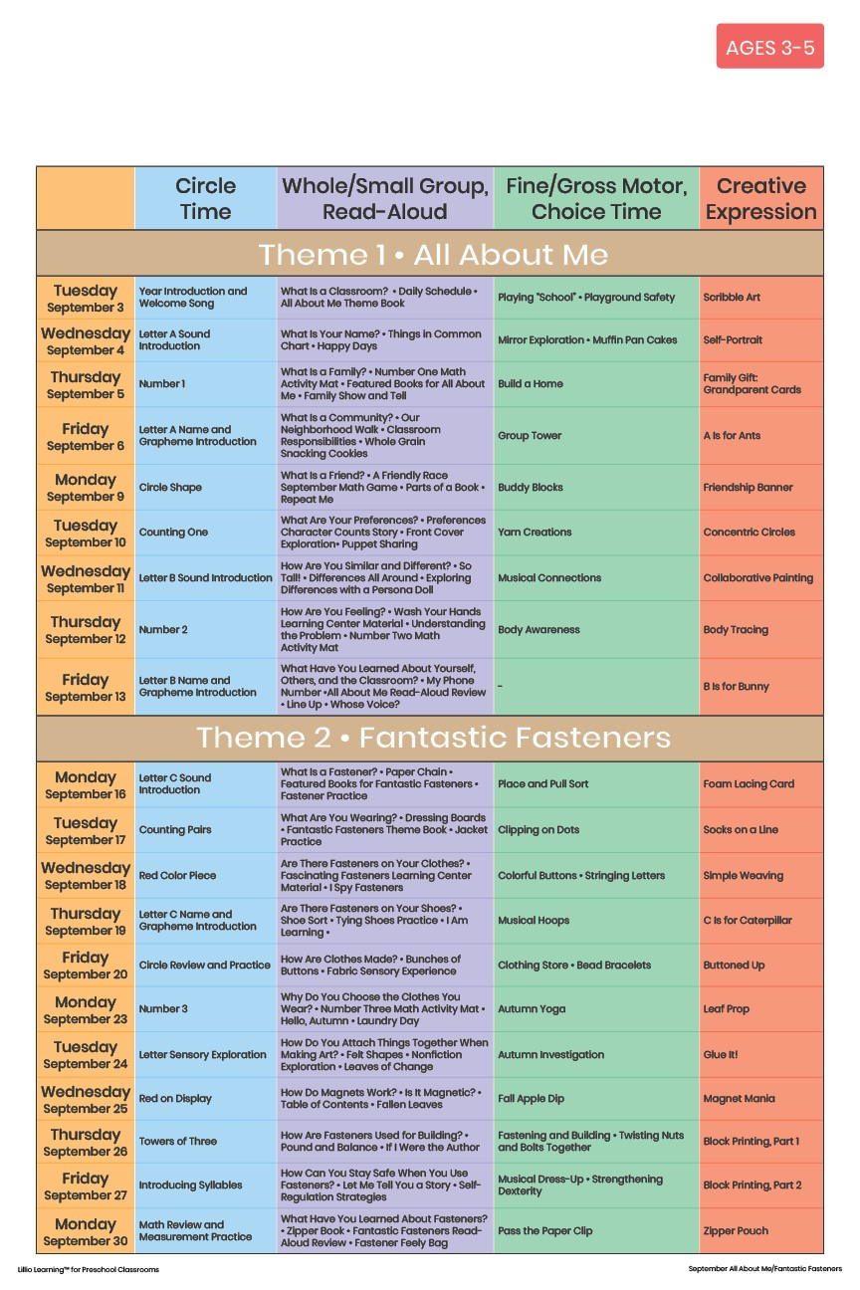

Add Your Name/Logo Here

October 2024