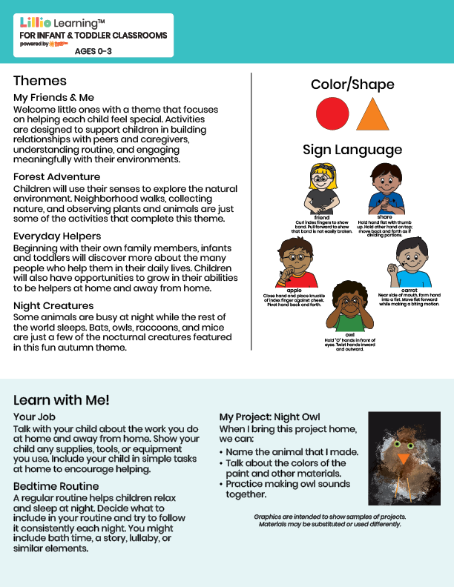

Add Name or Logo Here

Sept/Oct 2025

NEWSLETTER

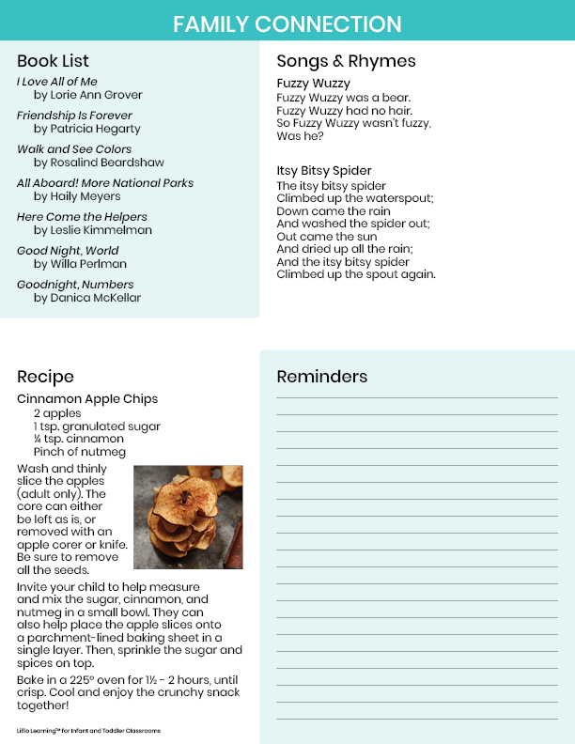

Add Notes Here