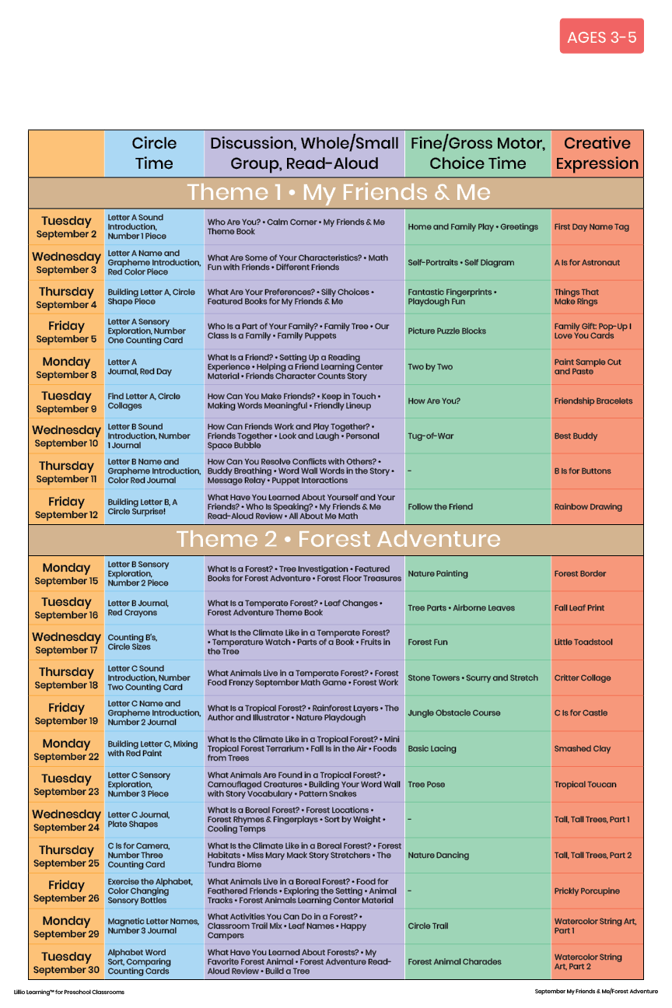

September 2025

Add Your Name/Logo Here