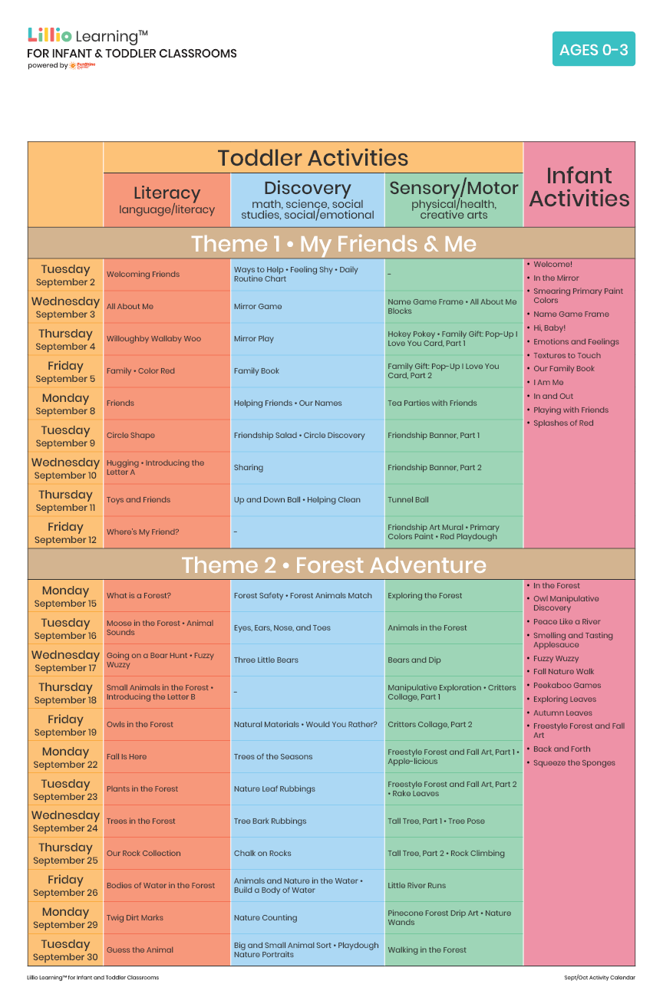

Add Your Name/Logo Here

September 2025

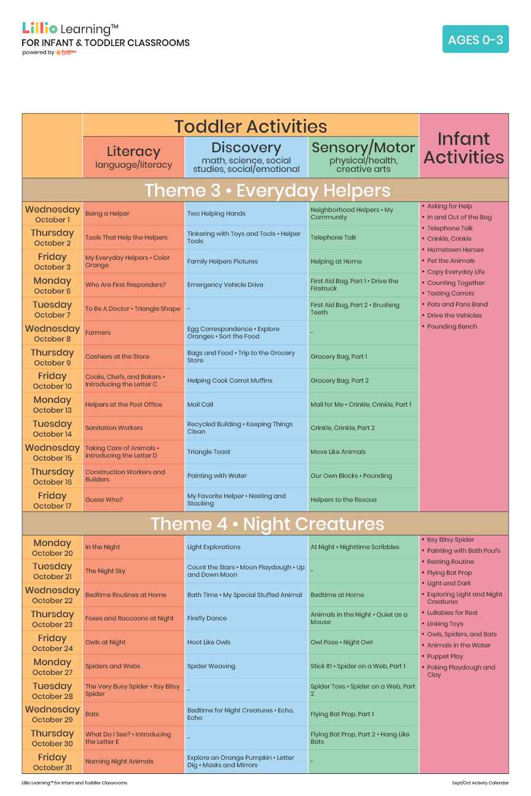

Add Your Name/Logo Here

October 2025